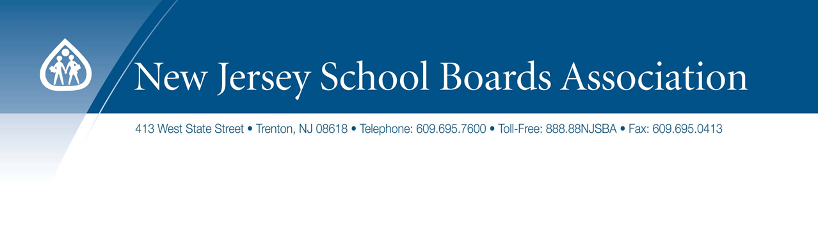
FREDON TOWNSHIP BOARD OF EDUCATION
Fredon Township School
Newton, N.J.
February 13, 2017

Anti-Bullying Bill of Rights Act
Where Are We Now?
The Role of the Board

Michael F. Kaelber, Esq., Director
Legal and Labor Relations Services Department, NJSBA

C.18A:37-15 Adoption of policy concerning harassment, intimidation or bullying by each
school district.

3. a. Each school district shall adopt a policy prohibiting harassment, intimidation or
bullying on school property, at a school-sponsored function or on a school bus. The school
district shall adopt the policy through a process that includes representation of parents or
guardians, school employees, volunteers, students, administrators, and community
representatives.

b. A school district shall have local control over the content of the policy, except that the policy shall contain, at a minimum, the following components:

(1) a statement prohibiting harassment, intimidation or bullying of a student;

(2) a definition of harassment, intimidation or bullying no less inclusive than that set
forth in section 2 of P.L.2002, c.83 (C.18A:37-14);

(3) a description of the type of behavior expected from each student;

(4) consequences and appropriate remedial action for a person who commits an act of
harassment, intimidation or bullying;

(5) a procedure for reporting an act of harassment, intimidation or bullying, including a
provision that permits a person to report an act of harassment, intimidation or bullying
anonymously; however, this shall not be construed to permit formal disciplinary action solely
on the basis of an anonymous report.

All acts of harassment, intimidation, or bullying shall be reported verbally to the school principal on the same day when the school employee or contracted service provider
witnessed or received reliable information regarding any such incident. The principal shall
inform the parents or guardians of all students involved in the alleged incident, and may
discuss, as appropriate, the availability of counseling and other intervention services. All
acts of harassment, intimidation, or bullying shall be reported in writing to the school
principal within two school days of when the school employee or contracted service provider witnessed or received reliable information that a student had been subject to harassment, intimidation, or bullying.

(6) a procedure for prompt investigation of reports of violations and complaints, which
procedure shall at a minimum provide that:

(a) the investigation shall be initiated by the principal or the principal’s designee within one school day of the report of the incident and shall be conducted by a school anti-bullying specialist. The principal may appoint additional personnel who are not school anti-bullying specialists to assist in the investigation. The investigation shall be completed as soon as possible, but not later than 10 school days from the date of the written report of the incident of harassment, intimidation, or bullying. In the event that there is information relative to the investigation that is anticipated but not yet received by the end of the 10-day period, the school anti-bullying specialist may amend the original report of the results of the investigation to reflect the information;

(b) the results of the investigation shall be reported to the superintendent of schools
within two school days of the completion of the investigation, and in accordance with
regulations promulgated by the State Board of Education pursuant to the “Administrative
Procedure Act,” P.L.1968, c.410 (C.52:14B-1 et seq.), the superintendent may decide to
provide intervention services, establish training programs to reduce harassment, intimidation, or bullying and enhance school climate, impose discipline, order counseling as a result of the findings of the investigation, or take or recommend other appropriate action;

(c) the results of each investigation shall be reported to the board of education no later than the date of the board of education meeting next following the completion of the
investigation, along with information on any services provided, training established,
discipline imposed, or other action taken or recommended by the superintendent;

(d) parents or guardians of the students who are parties to the investigation shall be
entitled to receive information about the investigation, in accordance with federal and State
law and regulation, including the nature of the investigation, whether the district found
evidence of harassment, intimidation, or bullying, or whether discipline was imposed or
services provided to address the incident of harassment, intimidation, or bullying. This
information shall be provided in writing within 5 school days after the results of the
investigation are reported to the board. A parent or guardian may request a hearing before
the board after receiving the information, and the hearing shall be held within 10 days of the request. The board shall meet in executive session for the hearing to protect the
confidentiality of the students. At the hearing the board may hear from the school antibullying specialist about the incident, recommendations for discipline or services, and any programs instituted to reduce such incidents;

(e) at the next board of education meeting following its receipt of the report, the board shall issue a decision, in writing, to affirm, reject, or modify the superintendent’s decision. The board’s decision may be appealed to the Commissioner of Education, in accordance with the procedures set forth in law and regulation, no later than 90 days after the issuance of the board’s decision; and

(f) a parent, student, guardian, or organization may file a complaint with the Division on Civil Rights within 180 days of the occurrence of any incident of harassment, intimidation, or bullying based on membership in a protected group as enumerated in the “Law Against Discrimination,” P.L.1945, c.169 (C.10:5-1 et seq.).

(7) the range of ways in which a school will respond once an incident of harassment,
intimidation or bullying is identified, which shall be defined by the principal in conjunction
with the school anti-bullying specialist, but shall include an appropriate combination of
counseling, support services, intervention services, and other programs, as defined by the
commissioner;

(8) a statement that prohibits reprisal or retaliation against any person who reports an act
of harassment, intimidation or bullying and the consequence and appropriate remedial action
for a person who engages in reprisal or retaliation;

(9) consequences and appropriate remedial action for a person found to have falsely
accused another as a means of retaliation or as a means of harassment, intimidation or
bullying;

(10) a statement of how the policy is to be publicized, including notice that the policy
applies to participation in school-sponsored functions;

(11) a requirement that a link to the policy be prominently posted on the home page of the school district's website and distributed annually to parents and guardians who have children
enrolled in a school in the school district; and

(12) a requirement that the name, school phone number, school address and school email address of the district anti-bullying coordinator be listed on the home page of the school district’s website and that on the home page of each school’s website the name, school phone number, school address and school email address of the school anti-bullying specialist and the district anti-bullying coordinator be listed. The information concerning the district antibullying coordinator and the school anti-bullying specialists shall also be maintained on the department’s website.

c. A school district shall adopt a policy and transmit a copy of its policy to the
appropriate executive county superintendent of schools by September 1, 2003. A school
district shall annually conduct a re-evaluation, reassessment, and review of its policy, making any necessary revisions and additions. The board shall include input from the school antibullying specialists in conducting its re-evaluation, reassessment, and review. The district shall transmit a copy of the revised policy to the appropriate executive county superintendent of schools within 30 school days of the revision. The first revised policy following the effective date of P.L.2010, c.122 (C.18A:37-13.1 et al.) shall be transmitted to the executive county superintendent of schools by September 1, 2011.

d. (1) To assist school districts in developing policies for the prevention of harassment, intimidation, or bullying, the Commissioner of Education shall develop a model policy applicable to grades kindergarten through 12. This model policy shall be issued no later than December 1, 2002.

(2) The commissioner shall adopt amendments to the model policy which reflect the
provisions of P.L.2010, c.122 (C.18A:37-13.1 et al.) no later than 90 days after the effective
date of that act and shall subsequently update the model policy as the commissioner deems
necessary.

e. Notice of the school district's policy shall appear in any publication of the school
district that sets forth the comprehensive rules, procedures and standards of conduct for
schools within the school district, and in any student handbook.

f. Nothing in this section shall prohibit a school district from adopting a policy that
includes components that are more stringent than the components set forth in this section.

