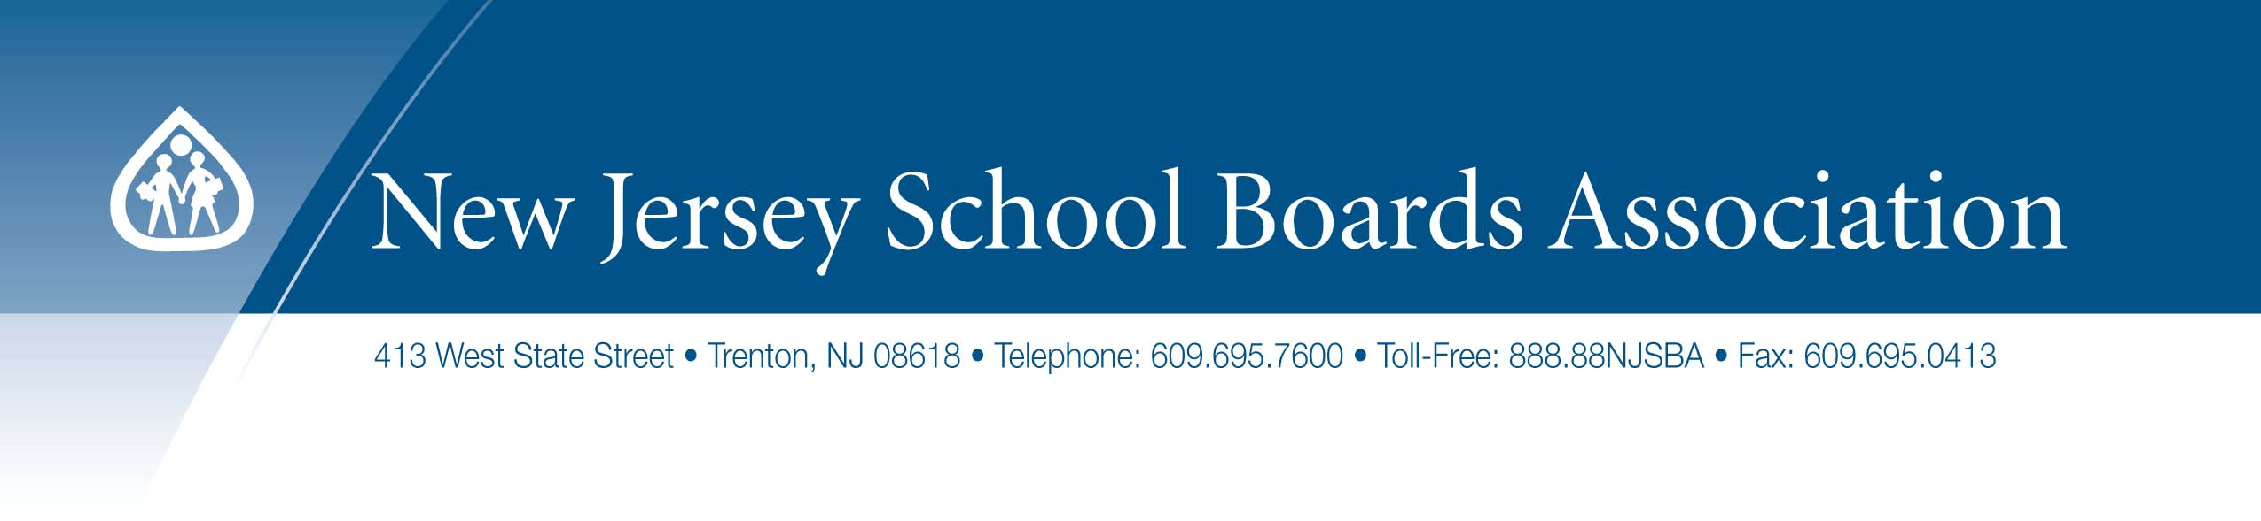
Code of Conduct for Remote Meetings
_____ Board of Education

Recognizing that, owing to the COVID-19 pandemic and Governor Murphy’s Executive Order #107 and subsequent guidance from the Division of Local Government Services of the New Jersey Department of Community Affairs, the _____ Board will be conducting its meetings exclusively using remote communications equipment for the foreseeable future.

The members of the ____ Board of Education also recognize that, in keeping with the School Ethics Act, we wish to command the respect and confidence of the people at all times, to avoid conduct which is a violation of the public trust, and to avoid creating any justifiable impression that such trust is being violated.

Therefore, the members of the _____ Board of Education voluntarily agree to the following Code of Conduct for Remote Meetings of the Board and its committees.

- We will keep our meetings focused on the issues and items delineated in the meeting agenda.
- We will respect the role of the meeting presider, the board secretary, and the superintendent, in accordance with our bylaws.
- We will focus on the business of the meeting without distraction or multi-tasking.
- Prior to the meeting, we will test-run our equipment to ensure a smooth call to order.
- We will endeavor to join the meeting from a quiet location.
- We will dress, speak, and act in a professional manner.
- In order to be fully present for the members of our public, and for consistency among all board members, all those on the virtual dais will use video unless it is impossible to do so, utilizing a well-lit space with the camera at or close to eye-level.
- We will silence our microphones or mute our outgoing audio unless speaking.
- The presiding officer will ensure that all members on the virtual dais who wish to contribute to discussion, in the proper course of the agenda, will have the opportunity to do so.
- All speakers will identify themselves prior to making remarks.
- Public comment will be conducted in accordance with our bylaws. Only the presiding officer responds to comments from the public. The presiding officer, if he or she deems it appropriate, may invite a person on the virtual dais to respond to a comment from a member of the public.
- All members who participate in Executive Session will do so behind closed doors without any non-members of the board being present.
- Those participating in Executive Session will use remote access methods that do not allow non-board members to hear or see the proceedings.
- No portion of the proceedings of Executive Session shall be recorded, photographed, or otherwise reproduced in a visual or audio format by anyone.
- Upon adjournment, all members will leave the meeting promptly.

