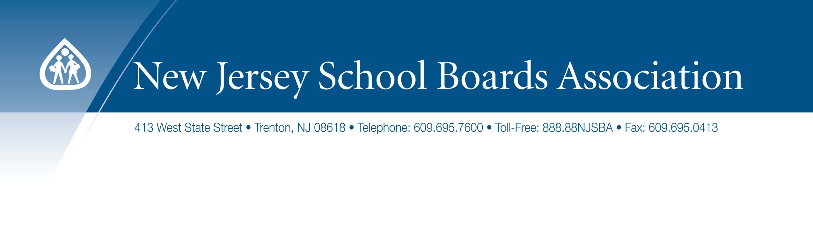
Resolution Opposing the Proposed Increases to the School Employees Health Benefits Program

WHEREAS, the School Employees Health Benefits Program (SEHBP), governed by N.J.S.A. 52:14-17.46 et seq., offers medical, prescription drug, and dental coverage to participating school district employees, retirees, and eligible dependents; and

WHEREAS, all SEHBP plans are self-funded, meaning that the money paid out for benefits comes directly from an SEHBP fund supplied by participating local employers and member premiums; and

WHEREAS, the Division of Pensions and Benefits is responsible for the daily administrative activities of the SEHPB, the School Employees Health Benefits Commission is the executive organization responsible for overseeing the SEHBP; and

WHEREAS, the School Employees Health Benefits Commission, comprised of state officials, union representatives and a representative of the New Jersey School Boards Association, annually considers the calendar year premium levels for the Local Education Employee Group of the SEHBP based on recommendations found in the Rate Setting Recommendation Analysis of the Local Education Employee Group; and

WHEREAS, the School Employees’ Health Benefits Plan Design Committee has the responsibility for and authority over the various plans and components of the plans, including for medical benefits, prescription benefits, dental, vision, and any other health care benefits, offered and administered by the SEHBP; and

WHEREAS, existing law requires three members of the School Employees’ Health Benefits Plan Design Committee to be appointed by the Governor as representatives of public employers (i.e., local school districts) whose employees are enrolled in the program, but currently all such representatives are state-level appointees;

WHEREAS, the recommended rate changes for medical and prescription drug coverage for the Active 2023 Local Education Employer Group is 15.1%, which includes a 15.3% increase for active employees enrolled in NJ DIRECT 10/15 and a 14.9% increase for active employees enrolled in the NJ Educators Health Plan (NJEHP); and

WHEREAS, such proposed exorbitant rate increases will fall upon the local property taxpayer, as well as school employees, at a time where there is record inflation; and

WHEREAS, since employees enrolled the NJEHP pay a percentage of salary toward their health benefits per P.L.2020, c.44, commonly referred to as “Chapter 44”, any increase in NJEHP premiums will fall almost entirely upon local boards of education, placing a severe strain on their budgets; and

WHEREAS, the proposed premium increase for most active employees will take thousands more out of their paychecks annually and lead to huge costs for local school districts that will translate into higher property tax bills for struggling families; and

NOW, THEREFORE, BE IT RESOLVED, by the (insert name of board of education) in the county of (insert name of county) call upon the School Employees Health Benefits Commission to reconsider the rate increase and strike a rate increase that is appropriate in the current economic conditions; and

BE IT FURTHER RESOVLED, that the (insert name of board of education) in the county of (insert name of county) urge the Legislature to adopt legislation expanding the composition of the School Employees Health Benefits Commission and the School Employees’ Health Benefits Plan Design Committee to include additional representatives from local school district management; and

BE IT FURTHER RESOLVED, that the (insert name of board of education) in the county of (insert name of county) urge the Legislature and executive branch to examine the impact that “Chapter 44” has had on school district budgets and to adopt legislation that will reverse any of its negative consequences and provide relief to those districts; and

BE IT FURTHER RESOLVED that a copy of this resolution be forwarded to Governor Murphy, State Treasurer Muoio, Senate President Scutari, Assembly Speaker Coughlin, (insert name of Senator), (insert names of Assembly Representatives), and the New Jersey School Boards Association.

