Click here if you are having trouble viewing this message.

Please forward this message to potential candidates in your county.
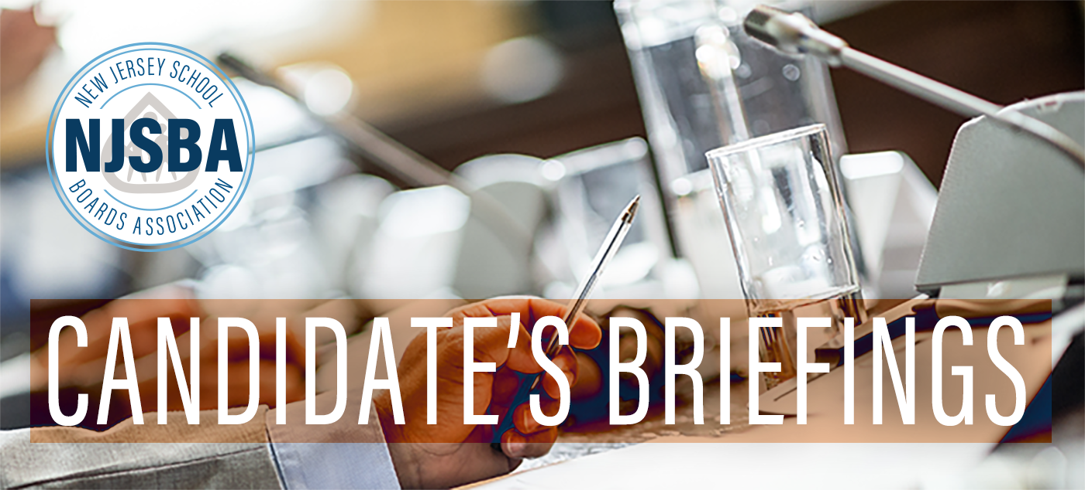
Regional Informational Program for School Board Candidates
The New Jersey School Boards Association (NJSBA), a non-regulatory, statewide association of all public school districts in New Jersey, provides support to our boards of education and their members. NJSBA is here to help you, beginning now!
NJSBA is hosting in-person regional Candidate's Briefings to address the structure and responsibilities of local school boards in New Jersey. Participants will receive pertinent information on topics including:
- An overview of the role of the board member
- Legal requirements, including criminal background checks and financial disclosures
- The board as a policy-making body
- Mandated training requirements
- Ethical considerations to avoid conflicts of interest
- Resources available to board members

This program is available at no cost to the candidates or their districts. All programs will feature the same content and run from 7 p.m. to 8:30 p.m., with registration beginning at 6:30 p.m. Please attend at a location most convenient for you!
Central Region
Wednesday, Sept. 23
Somerset County Vocational & Technical Schools
14 Vogt Drive, Bridgewater, NJ 08807

Southern Region
Thursday, Sept. 24
Glassboro High School
550 Joseph L Bowe Blvd., Glassboro, NJ 08028

Northern Region
Monday, Sept. 28
Manchester Regional High School
70 Church Street, Haledon, NJ 07508​​​
Register For Your Program

For more information, contact Marie Marcantonio at 1-888-886-5277, ext. 5210 or mmarcantonio@njsba.org.
Explore NJSBA’s Candidate’s Kit A menu of critical online resources for School Board Candidates. Learn more.

